
Week 13 Day 2
AZURE HANDS ON

May 12, 2026
Bharath Yalagi
UpGrad Batch 3
- Create VNet, SubNets

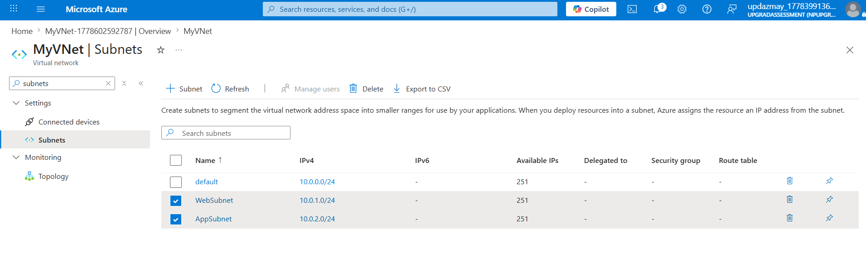
I created an Azure Virtual Network to establish a private cloud network environment. Inside the VNet, I created multiple subnets to logically separate application resources for better security and network management.

- NSG + Rules + Bind With SubNets

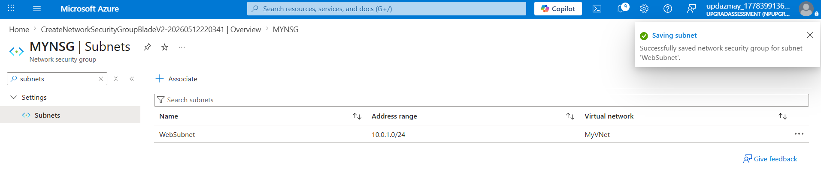
I created a Network Security Group to control inbound and outbound traffic using security rules. Then i associated the NSG with a subnet to secure all resources inside that subnet using HTTP, HTTPS, and RDP rules
- Virtual Machine + RDP

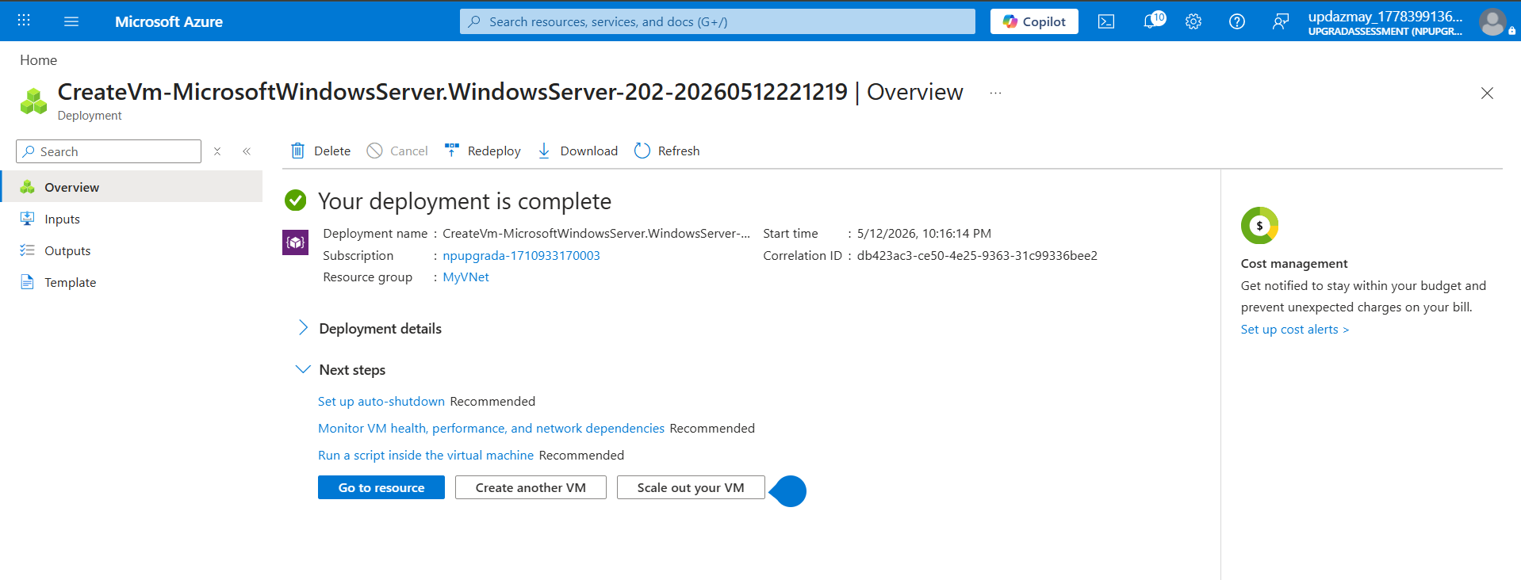
RDP FILE
- full address:s:20.115.98.91:3389
- prompt for credentials:i:1
- administrative session:i:1
- username:s:azureuser1

- NEW WINDOWS OPENED AND ACCESSIBLE
Azure generates an RDP configuration file containing VM public IP, port number, and connection settings. Using this file, we can remotely access Windows virtual machines securely over RDP protocol.

- Azure SQL Database

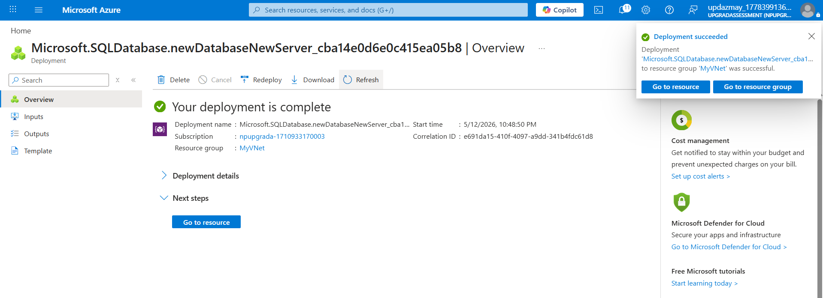

Azure SQL Database is a fully managed relational database service provided by Microsoft Azure. It eliminates manual infrastructure management and provides scalability, backup, security, and high availability

